Student Id – IT24100860

Name – Fernando S.K

Lab sheet 10

1

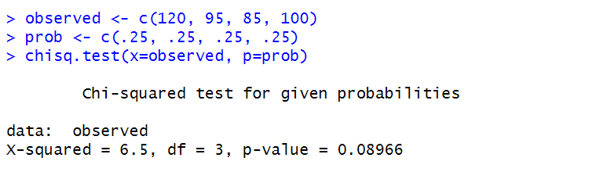

2

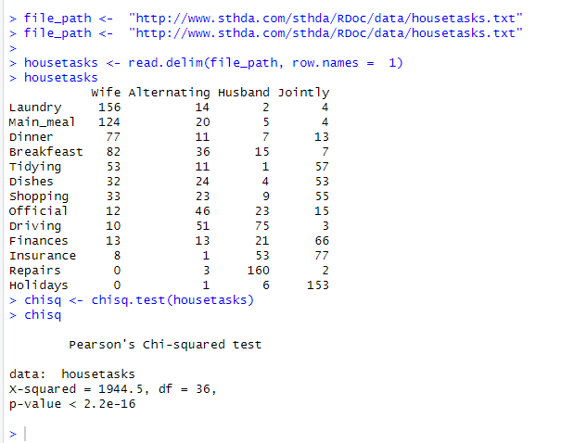

3

